Website Design & Development

Proposal For

Myagdi Multiple Campus
Beni, Myagdi

“Freedom to decide
however you choose”

SoftLab Inc.
Baneshwor, Kathmandu
Contact No.: +977-01 44 82 469
Email: mail@softlabinc.com
Url: www.softlabinc.com | www.paathshala.com.np

Dated: March 29, 2018

To,
The Campus Chief
Myagdi Multiple Campus
Beni, Myagdi

Subject: About reconstruction of website for your campus.

Dear Sir,
With reference to the above mentioned subject, I would like to put forward a proposal for the re-construction of the website for your esteemed organization.

The new website will be developed using the latest technology (Asp.net and C#) to provide rich and easy interface to surf. By using the administrative control panel all the content of the website can be updated instantly from anywhere in the world using the internet.
The price and terms of services regarding the use and development of the website has been attached herewith.
We wish to hear from you soon.
Sincerely,

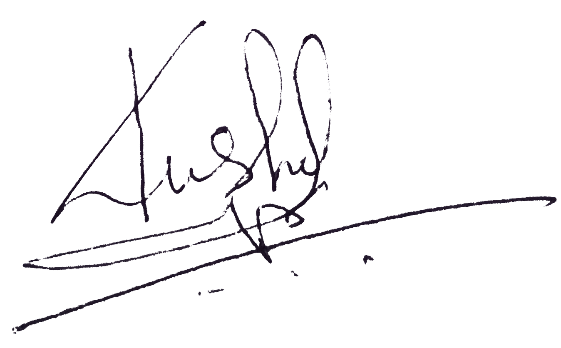
……………………
Kushal Kathayat
Chairperson
Contact Number: 9849165585
E-mail: kushal@softlabinc.com
SoftLab Inc.

1. Executive Summary
1.1 The Objective
Your esteemed concern is in need of new website to update the information, news and notices to the general public/customer. The proposed system will provide a layout and administrative control panel to update and share information in a click.
1.2 The Goals
Your esteemed concern requires professional, dynamic and easy to control website in a cost effective manner.
The goals of new website are:
1. Provide easy interface to surf the webpage and to display the contents.
2. Provide simple administrative control panel to easily update and share the latest information.
3. Provide high security mechanism for controlling website from being hacked.

1.3 The Solution
The proposed website will provide easy and simple interface. The system will include following features.
Special features of new website:
- Easy to use and surf: Simple and user friendly layout.
- Air tight security: Unauthorized person access not allowed in the administrative control panel.
- Real-time information update: By using the latest administrative control panel, admin or authorized person can update information, news, latest events and photos easily and quickly.
2. The Project

2.1 Web Package
The following are the web packages recently offered by our company.

Web Space (For Single Website) | 2 GB
No. of Email | Unlimited
Website Development Cost | 75,000/-
Recurring Charge (Annual for Website Space) | 10,000/-
Standard Disclaimer: Above rates are excluding government taxes.
Above mentioned charges are subject to be change.
2.2 Contract & Terms
- The contract of website is valid for 5 years. The period of contract can be extended.
- 50% of the total cost should be paid to the developer at the time of contract signing for the development of this website.
- The remaining amount must be paid within 1 week after the website is completely implemented.

2.3 Project Development Phase
S.N. | Phase Name | Required Time
1. | Website Design and Development | 2 weeks (after the agreement)
2. | Website Testing | 1 day
3. | Website Implementation | 1 day

