

Date: 2020/02/16

To
NIC Asia Bank Limited
Kathmandu, Nepal

Subject: Regarding H2O api agreement renewal

Dear sir,
We would like to remind you that our H2O api agreement was expired on 2nd February, 2020. To auto-renew our agreement please send us letter mentioning the renewal of the api. As per our agreement api renewal cost will be NRs. 16,950/-.

Sincerely,
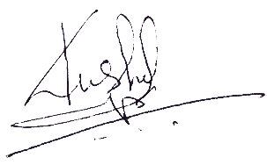

-------------------
Kushal Kathayat
Chairperson

